Womack CVE gameplan:

- The most common error we are seeing on the CVE list for womack is on port 1433, with the issue residing in the ms-sql-s (version 2017, 14.00.2085)

What I have found, is that if we patch over to the newest versions of the ms-sql-s we should be able to negate those CVEs

The long term fix we can do, would be to remove any direct internet exposure to that specific port, potentially filtering what can, and cannot touch it.

Anderson Capital gameplan:

- The most common error we are seeing on the CVE list for ACP would be these below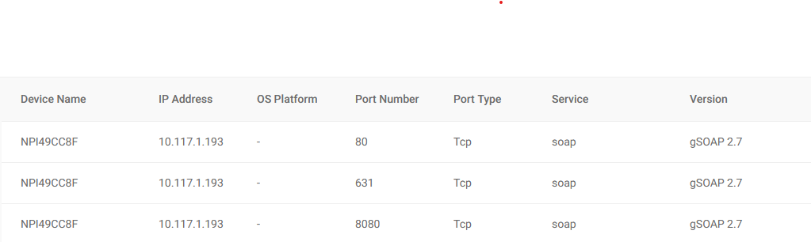

Therse are more than likely being caused by old HP printer drivers, The reason I know its HP for the most part is due to the NPI naming conventions, and also the ports that it is using, also the gSOAP is a service commonly left open by HP

